Core Concepts and Container Fundamentals
Pets vs. Tin Soldiers (Analogy):
  - Pets: Unique virtual machines (VMs) with state, requiring individual care (patching, healing). Examples include domain controllers or SQL servers.
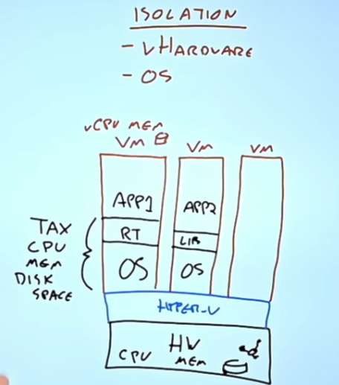
  - Tin Soldiers: Identical, stateless clones (containers), disposable and replaceable without unique identity or state. This model shifts responsibility away from managing OS and runtimes to focusing solely on the application.
Virtual Machines vs. Containers:
  - VMs virtualize hardware with each VM running its own OS kernel, isolating apps but with a significant overhead (CPU, memory, disk). Provide strong isolation between VMs since each has separate kernel and user space. Slower provisioning, portability issues, management complexity.
  - Containers virtualize the operating system, sharing the host OS kernel but isolating processes and filesystems via namespaces, and cgroups for resource control, enabling sub-second startup (enabling small lifecycles) and efficient resource use. Run as lightweight sandboxes with isolated user mode spaces but share the same kernel.
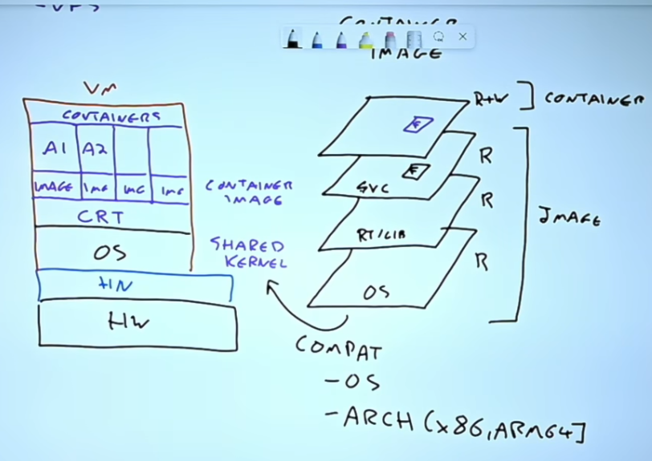
  - Containers rely on Linux kernel namespaces (PID, NET, MNT, UTS, IPC, USER) to isolate processes. Each container gets its own "view" of system resources, like process IDs, network interfaces, and file systems. Control groups (cgroups) limit and account for CPU, memory, and I/O usage. This ensures one container doesn’t hog resources.
Container Images and Layers:
  - Container images are composed of immutable, read-only layers (base OS, runtimes, app dependencies). Containers mount these layers read-only, plus a top read-write layer added at runtime. Images are built using Dockerfiles, which are declarative scripts describing: The base image (e.g., official httpd image for Apache) ; Commands to modify or add files (copying website content, removing defaults). So an app image will have a base image like httpd (itself built of many layers), and then add layers of its own.
  - Image base layer must be compatible with the host OS kernel and architecture (e.g., Linux containers on Linux hosts). Layer sharing and caching (across images) reduce storage and network costs.
  - Every container has a PID 1 process (the "init" of the container). This process defines the container’s lifecycle. If PID 1 exits, the container stops. Other processes inside the container are children of PID 1.
Container Runtime Components:
  - Docker (High-Level Tooling): is the developer-facing CLI and API. It handles building images, managing networks, volumes, and orchestrating containers. It used to have its own runtime, but now delegates container execution and lifecycle operations to containerd.
    - ContainerD (runtime) - A core container runtime maintained by CNCF. A long-running daemon that manages container lifecycle and low level tasks (start, stop, pause, snapshot, image pull). Docker uses containerd under the hood to actually run containers. Exposes APIs (gRPC) for higher-level tools like Docker or Kubernetes. Delegates the actual container execution to runC. Kubernetes also uses containerd directly (via CRI – Container Runtime Interface).
    - RunC (low-level OS interface for container creation) - Implements the OCI runtime spec. Given a container bundle, it sets up namespaces, cgroups, mounts, and executes the container’s PID 1. It’s invoked by containerd whenever a container needs to be started.
    - Docker → containerd → runC → Linux kernel . Docker is the user-facing interface. containerd is the orchestration engine. runC is the executor that actually spawns the container process.
Hyper-V Containers (isolated kernel): Offer stronger isolation by running containers inside thin VMs, trading off some efficiency for security in multi-tenant environments. Without this containers would have a shared kernel space, which is noot good for security.

Native Windows kernel cannot run Linux containers directly because namespaces and cgroups are Linux-specific. Docker Desktop uses a Linux VM (via WSL2 or Hyper-V) to host Linux containers. So, you can run Linux containers on Windows, but they’re actually running inside a Linux kernel VM. Windows containers require the Windows kernel. They cannot run natively on Linux. To run them, you’d need a Windows Server host or a VM with Windows kernel. Containers are OS-kernel dependent. They are not like VMs that emulate hardware; they share the host kernel. That’s why cross-OS containerization always involves virtualization.

Azure Container Services Overview
Service | Description | Key Features | Typical Use Cases
Azure Container Instances (ACI) | Container as a Service; simplest way to run containers without orchestration | Fast startup, public/private images, container groups (Linux only), virtual network integration (Linux only) | Short-lived jobs, burst workloads, simple tasks
Azure Kubernetes Service (AKS) | Managed Kubernetes orchestration platform | Managed control plane, node pools on VM scale sets, autoscaling (pods & nodes), multiple networking models, persistent volumes, managed identities, upgrades | Complex container orchestration, microservices
Azure Container Apps | Serverless container hosting built on AKS, abstracts Kubernetes | Built-in Dapr (distributed runtime), KEDA (event-driven autoscaling), Envoy sidecar for networking | Microservices without Kubernetes complexity
Azure Spring Apps | Managed Spring Cloud environment on AKS for Java Enterprise apps | Open-source or VMware Tanzu-based, supports Spring Boot microservices, service discovery, traffic management | Java/Spring developers wanting managed environment
Azure App Service | Original PaaS for hosting web apps including containers | Supports multiple runtimes (.NET, Node.js, Python, Java), Windows/Linux containers, autoscaling, deployment slots, VNet integration, app migration support | Web apps, APIs, legacy app modernization
Azure Functions | Serverless compute platform for event-driven code | Supports many languages, integrates with Event Grid, pay-per-use model | Event-driven workflows, automation
Logic Apps | No/low-code graphical workflow automation | Extensive connectors, built on Azure Functions runtime | Business workflows, integration without coding
Azure Static Web Apps | Globally distributed hosting for pre-rendered static content with optional serverless APIs | Free/Standard SKUs, integrated with GitHub/Azure DevOps, supports managed functions for backend logic | Static sites, SPA, JAMstack apps

Azure Kubernetes Service (AKS) Deep Dive
Architecture:
  - The control plane (API server, scheduler, etcd, controllers) is fully managed by Azure. You don’t see or manage these VMs — they’re abstracted and provided as a managed service. Azure handles upgrades, scaling, and high availability of the control plane.
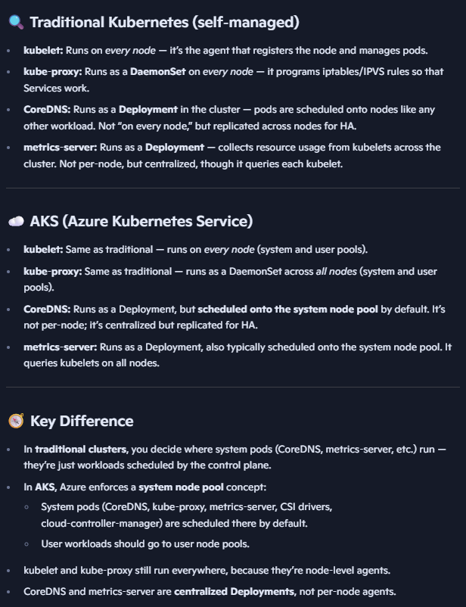
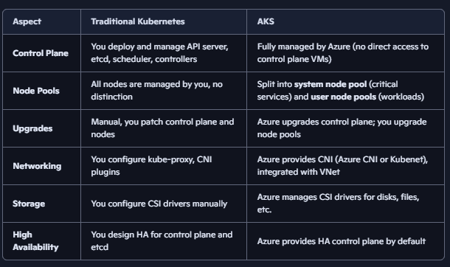

  - Worker nodes run container workloads in pods, managed via node pools (>=1) built on VM scale sets. You can have multiple node pools with different VM sizes, OS types (Linux/Windows), or configurations.
  - In AKS, system components like kubelet run on every node(Azure VM), but AKS introduces a special system node pool that hosts critical services (e.g., CoreDNS, kube-proxy, metrics server, azure specific agents). This differs from traditional Kubernetes. System node pool can run user workloads, but best practice is to reserve it for system services.
  - You only pay work worker nodes. SKUs: Free, Standard (SLA, 5000 nodes, AZs).
Scaling:
  - Horizontal Pod Autoscaler (HPA): Scales pods based on CPU/memory or custom metrics.
  - Cluster Autoscaler: Adds/removes VMs (nodes) if pods cannot be scheduled or resources are underutilized.
  - KEDA (K8s Event Driven Autoscaling): Allowing scaling on external events (e.g., queue length).
Networking: Multiple networking options including:
kubenet - node gets ip in subnet, pods get ip from internal non-routable range. outbound traffic is NATed through node’s IP. To allow pods on different nodes to talk to each other, Kubenet programs user-defined routes (UDRs) in the Azure route table, Each node advertises the pod CIDR range it owns and needs one route entry. Other nodes use that route to reach pods on that node. Limits no. of nodes to 400 due to limit on route table entries.
Azure CNI - pods get IPs from same vnet subnet as node. Seamless integration with Azure services (firewalls, NSGs, load balancers). Pods can be directly reached from other Azure resources. large clusters can exhaust subnet IPs.
dynamic CNI - pods get IPs from different subnet as node. Pods are assigned IPs only when scheduled, not pre-reserved.
CNI overlay - like kubenet but not using route tables. Pods get IPs from a separate private CIDR (overlay network). Overlay IPs are mapped to VNet IPs for communication. Avoids VNet IP exhaustion. Slightly more complex routing. Overlay adds abstraction, which can complicate troubleshooting.
Storage:
  - Persistent storage through Persistent Volume Claims (PVCs) backed by Storage classes (Azure Disks, Files, Blob, or third-party solutions) to support stateful applications like databases.
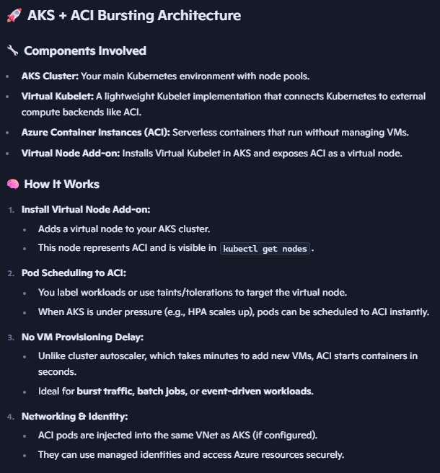
Node Pools and Taints/Tolerations:
  - Support for multiple node pools (system and user workloads), including spot VMs and GPU-enabled nodes. Taints and tolerations allow scheduling of specific pods to specific nodes.
  - AKS uses Azure Container Instances (ACI) for burst scenarios by integrating ACI as a virtual node via the Virtual Kubelet. This allows AKS to instantly schedule pods to ACI when the cluster is under pressure, without provisioning new VMs—ideal for short-lived, stateless workloads.
Autohealing in AKS
AKS continuously monitors node health. If a node becomes NotReady (e.g., kubelet crash, VM issue, networking failure), AKS will cordon and drain that node, then replace it with a fresh VM in the node pool. Uses Azure VM Scale Set health probes. Any ephemeral data on the node is lost (e.g., local /var/lib/docker or container ephemeral storage). Persistent data survives only if backed by Azure Disks, Azure Files, or other persistent volumes.
Upgrades & Maintenance:
  - Kubernetes versions follow semantic versioning (major.minor.patch) with ~12 months support per minor version.
  - Can upgrade control plane and nodes separately or whole cluster; Azure supports automatic upgrades with configurable channels (patch, stable, rapid). Nodes require OS patching and rebooting, which can be automated.
  - AKS does not patch nodes in place. Instead, it recreates nodes with the new image/version:
Cordon + drain old node.
Create new VM with updated image.
Reschedule pods onto the new node.
Delete the old VM.
  - Same as autohealing: ephemeral node data is lost. Persistent volumes remain intact because they’re Azure-managed resources, not tied to the node lifecycle.
Security:
  - Managed identities for pods enable fine-grained access to Azure resources using Azure AD workload identity, mapping Kubernetes service accounts to Azure AD identities.
Management:
  - Azure Portal provides full UI for namespace, pods, deployments, services, and ingress management.
  - Integration with GitOps (Flux v2) automates deployment from Git repositories.

Container Image Lifecycle and Registry Management
- Images are built using Dockerfiles specifying layered instructions.
- Images are stored and managed in registries: public (Docker Hub) or private (Azure Container Registry). Place close to deployment to reduce latency, increase reliability.
- Registries support geo-replication for faster regional access and high availability.
- Continuous integration pipelines can automate image builds, tests, and pushes to registries.
- Containers are immutable; patches involve rebuilding images with updated base layers rather than in-place patching.

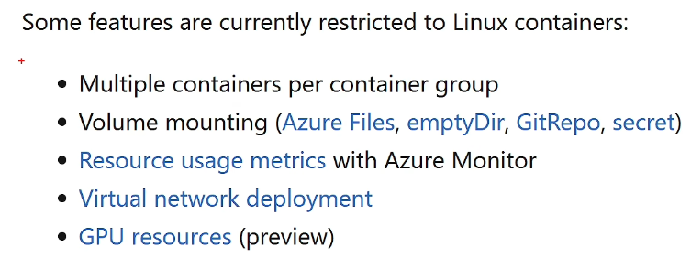
Azure Container Instances (ACI)
- Simplest container hosting option, no orchestration, quick spin-up/spin-down. Public or private(linux only due to virtual network deployment not available for windows)
- Supports Linux and Windows containers (with some feature limitations on Windows).
- Container groups enable multiple containers (Linux only) sharing localhost networking (each container connectible via localhost using different port) and storage. Common scenario: Sidecar containers.
- Ideal for burst workloads, simple jobs, or small-scale container hosting. Can integrate with AKS via Virtual kubelet.

Azure Container Apps
- Abstracts Kubernetes complexity while providing microservices features.
- Includes Dapr for distributed app runtime (service discovery, state management, pub/sub).
- Includes KEDA for event-driven autoscaling and Envoy for traffic management.
- Focuses on developer productivity and microservices patterns without deep Kubernetes knowledge.

Azure Spring Apps
- Managed service for Spring Boot and Spring Cloud Java applications.
- Available in Basic, Standard, and Enterprise tiers (Enterprise integrates VMware Tanzu).
- Provides cloud-native microservices capabilities like service discovery, traffic routing, centralized configuration.

Azure App Service
- Azure’s original PaaS for web hosting; supports multiple languages and runtimes.
- Supports both code deployments and containerized apps on Windows and Linux.
- App Service Plans manage resources (worker nodes) shared across multiple apps.
- Supports autoscaling, deployment slots (staging/production swap), and VNet integration.
- App Service Environment (ASE) provides isolated, fully managed environments inside customer VNets.

Serverless Options: Azure Functions & Logic Apps
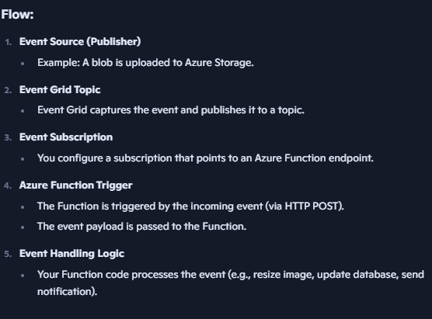
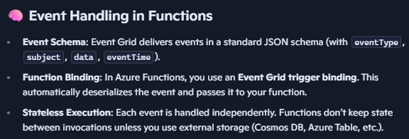
- Azure Functions: Code-centric, event-triggered, pay-per-use compute for running small pieces of code. Supports many languages and triggers. You write small pieces of code (“functions”) that run on demand. Trigger-based execution: Functions don’t run continuously; they’re invoked by triggers (HTTP requests, timers, messages, events). Event Grid is Azure’s event routing service. It delivers events from publishers (like Azure Blob Storage, Resource Groups, IoT Hub) to subscribers (like Functions, Logic Apps, or custom endpoints).
- Logic Apps: Graphical, no/low-code workflows integrating hundreds of connectors, built on Azure Functions runtime, ideal for business process automation.

Azure Static Web Apps
- Globally distributed hosting for pre-rendered static content (HTML, JS, CSS).
- Supports integration with Azure Functions for backend APIs with seamless CORS handling.
- Provides free SSL, custom domains, GitHub/Azure DevOps CI/CD integration.
- Suitable for SPA frameworks like React, Angular, Vue, or static sites.

GitOps and Helm: Simplifying Kubernetes Operations
- GitOps is a deployment methodology where the cluster pulls configuration from a Git repository (instead of pushing changes into the cluster).
  - Tools like Flux watch the Git repo for changes and automatically apply updated manifests.
  - Supports automatic image updates by detecting new container image versions and applying corresponding configuration changes.
- Helm is a package manager for Kubernetes that bundles multiple YAML manifests into a single unit called a Helm chart.
  - Helm charts separate configuration values into a single file (values.yaml), making complex deployments manageable, and can apply all yamls with single command like helm install.
  - Charts can be versioned and stored as OCI (open container initiative) artifacts in registries.
  - Helm simplifies installing, upgrading, and managing Kubernetes applications.

Security, Policy, and Best Practices
- Containers and Kubernetes support policy-as-code frameworks (e.g., Kubernetes Gatekeeper, Azure Policy) to enforce:
  - Security constraints.
  - Allowed volume types.
  - Resource limits.
  - Network policies.
  - Privileged container restrictions.
- Containers are treated as immutable cattle, not pets:
  - Instead of patching containers, new images are built and redeployed.
  - Deployment strategies like blue-green, canary, or rings ensure zero downtime during upgrades.

Key Insights
- Containers revolutionize app deployment by virtualizing OS, enabling rapid, lightweight, and portable workloads.
- Kubernetes is the de facto standard for container orchestration, and AKS offers a fully managed experience with rich features.
- Azure offers a spectrum of container and app hosting services to suit different use cases—from simple ACI to complex managed Kubernetes, to developer-friendly container apps and Spring apps.
- Serverless complements containerized apps by providing event-driven, scalable compute with minimal infrastructure management.
- Azure Static Web Apps offer a simple, performant way to serve static content globally with optional serverless APIs.
- Choice of service depends primarily on use case, developer skillset, app architecture, and operational complexity.
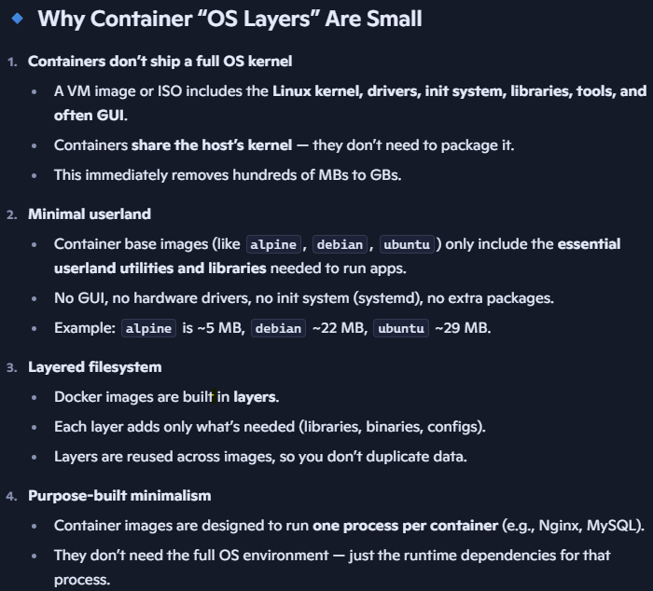
- Yamls are stored in repository. Images are stored in registry.

